Multisim Installation Tutorial

# VE270 TA team

1. Please go to: <http://www.ni.com/gate/gb/GB_ACADEMICEVALMULTISIM/US>
2. Create a new NI account
3. Click Start Download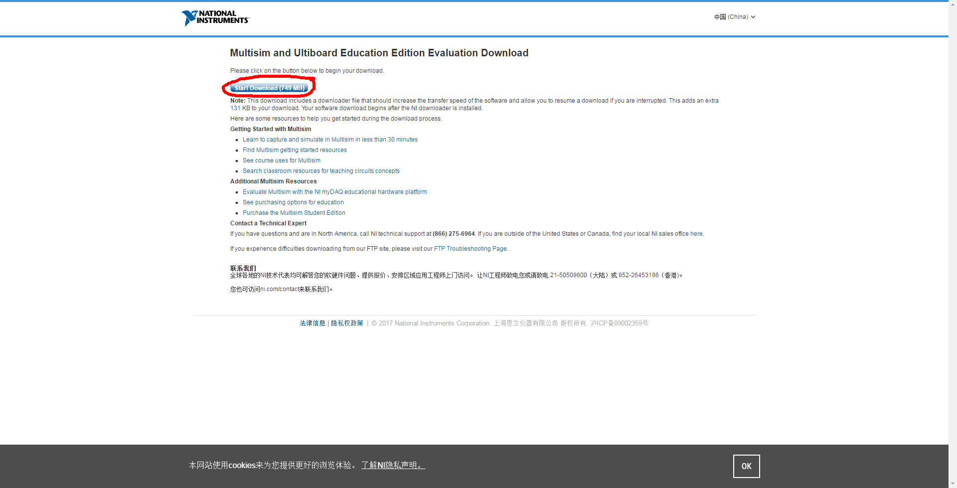
4. Choose a directory to download the NI Design Suite Edition 14.1.
5. Starting downloading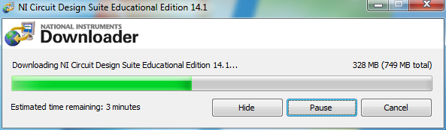
6. Choose a directory to unzip the files.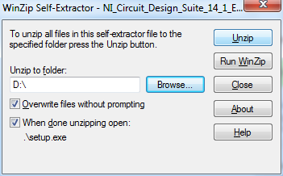
7. Find the directory that you unzip your files in Step6, and double click on setup.exe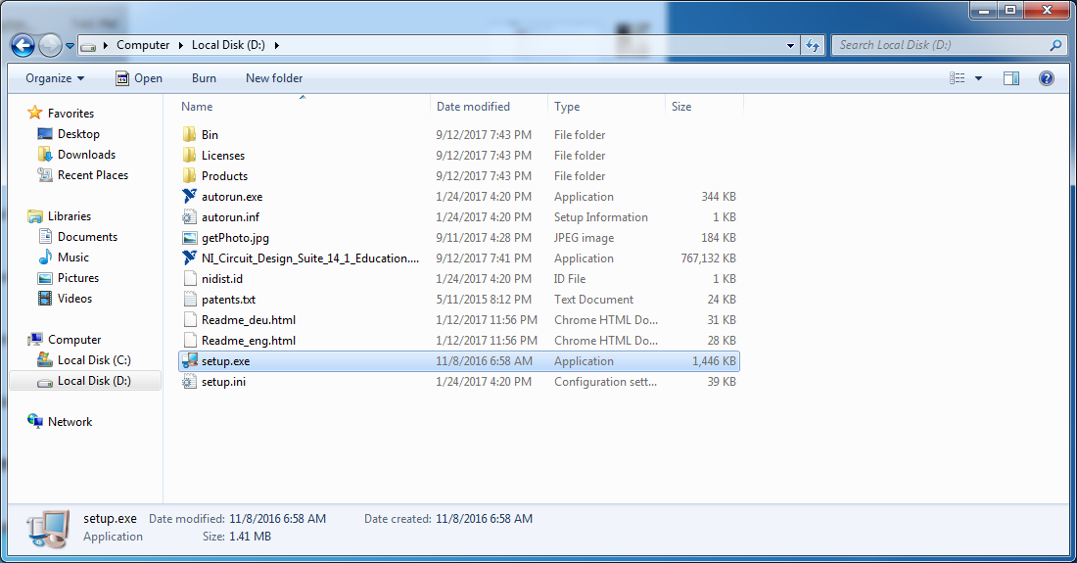
   1. For some computers you may lack certain environment that the program needs to be fit in (especially in those old versions of windows). Install what is needed and then follow the rest steps.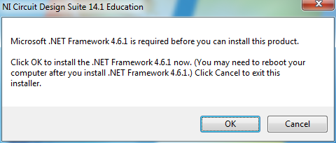
8. Choose “Install this product for evaluation”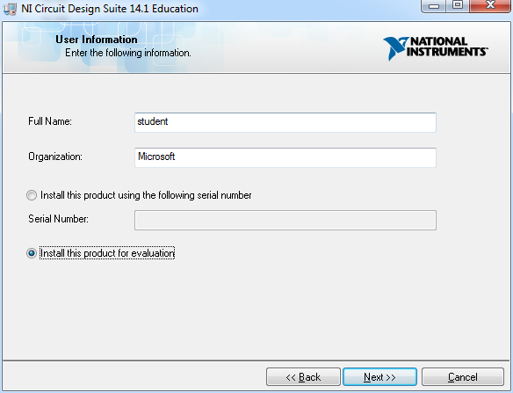
9. Select a destination directory you would like to install Multisim to.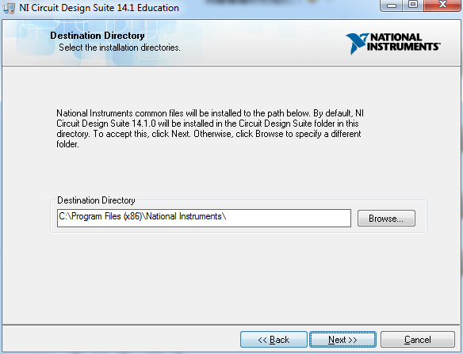
10. You can deselect the “NI ElVISmx” item in this step, or you can just leave it as default.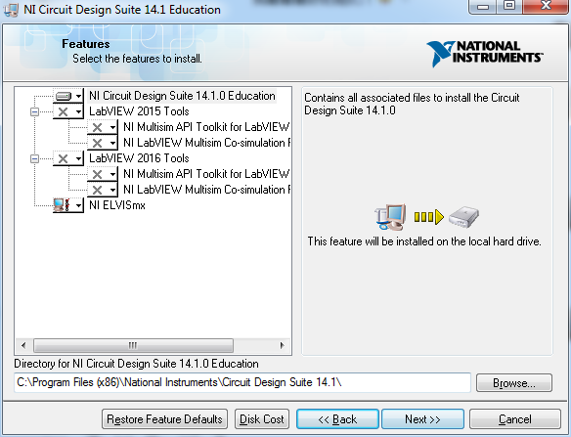
11. Deselect as the following pic.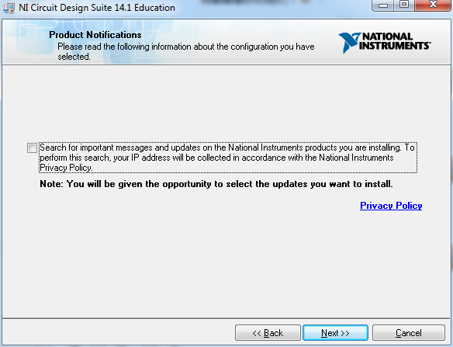
12. Select “I agree the above 2 License Agreement(s).”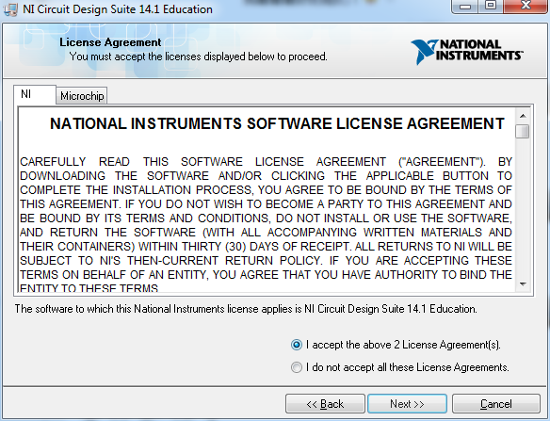
13. Here the installation begins. 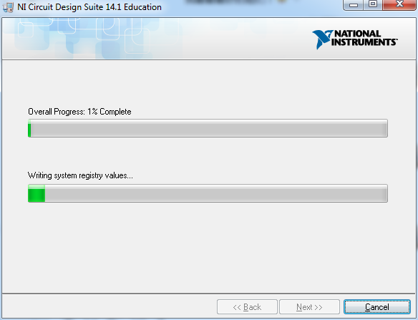
14. Select cancel if this window pop up.

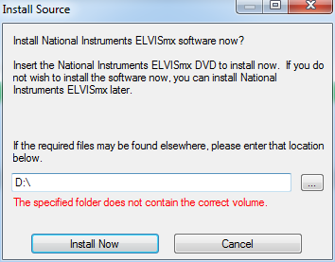

1. The installation completes. Enjoy.

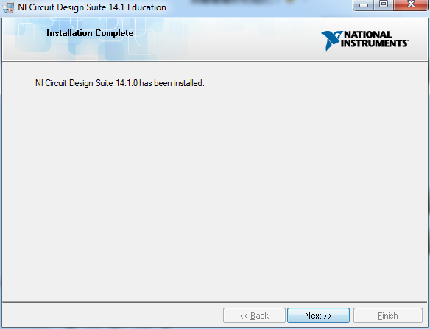

1. You can extend the probation period to 45 days, which is enough for our course.